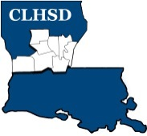
Central Louisiana Human Services District
Board Meeting Agenda
March 5, 2020 @ 9:00 a.m.

- Call to Order/Quorum
- Prayer/Pledge

- Read and Approve March 2020 Meeting Agenda
- Solicit Public Comment Requests

- Adjourn Board Meeting to begin Retreat

- Reconvene Board Meeting after completion of Retreat

- Approval of February 2020 Minutes

- District Reports

  - Financial Report- H1

  - ED Monthly Report H2

- Board Business
  - Executive Session
Ex
- Next Month
  - Policy Reviews – Executive Limits
- II.H. Compensation and Benefits – Rebecca Craig
- II.K. Community Relationships – Rebecca Craig
  - Board Development/Training Save Cenla – Applied Suicide Intervention – Angie and Andy Dixon and the Extra Mile
  - Tier 2.1 – Covering Calendar Year 2019 due by May 15th
  - Annually Ethics training for the current year to be completed by the May meeting

- Questions/Comments As Solicited

- Announcements
- Next meeting is April 2, 2020
- Adjourn

